Data Visualizing and Forecasting Methodology for vivid Analysis of COVID-19 cases in India

Mohammed Azam Sayeed¹, Noor Ayesha²
¹Department of Computer sciences, SET Jain University Bangalore -562112

Abstract— This paper presents various data visualization techniques using Plotly, matplotlib to extract insights from covid-19 data exclusively for india, due to its concerns being 2nd most populous country in the world and help in taking pre-emptive steps to reduce risk of india becoming next hotspot. Also the paper explains various prediction techniques that can help in governments to assess the risk and take necessary steps to curve the impact.

Keywords—Plotly, matplotlib, Corona virus, India, holt winter, fbprophet, ARIMA models, Data visualization,Web Scraping.
- Unprecedented times: coronavirus pandemic
The novel coronavirus that originated in Wuhan, China, has spread to almost all countries and declared as pandemic. The extent of this outbreak is rapid. It is hard to accurately assess the lethality of this virus and it appears to be far more fatal than the coronavirus that caused SARS and MERS. Scientists have identified two new strains of the coronavirus, indicating it’s already has been mutated at least once. The biggest challenge is an unknown number of people have been infected by the virus without becoming symptomatic. These people are carriers of the virus without themselves showing any signs. Initially, people who showed no signs of infection were not quarantined and this leads to the spread of the virus at a massive rate. The virus is also shown to affect its hosts very disproportionately. Children seem to be less likely to be infected while the middle-aged and older adults are inexplicably infected. Men are more likely to die from the infection compared to women, and also people with a weaker immune system, Type 2 diabetes and high blood pressure. But recently many perfectly healthy young individuals have died from the infection making it even harder to understand the effect of COVID-19. The symptoms of COVID-19 are general flu-like and some patients develop a severe form of pneumonia. Patients develop symptoms like fever, muscle and body aches, coughs and sore throat about after six days of contracting the infection. Most people feel very miserable and weak and get better on their own, but a minority of patients will get worse after 5-7 days of illness and the patients have shortness of breath and worsening cough. The cough is dry and not wet. It’s even seen that patients have strong headaches. And the symptoms very mildly different from the flu. Individuals infected from the virus may not have a cold. But some people don’t get sick while being infected and are spreading the virus to new hosts. These people should be not out and about spreading the disease. People who got infected and have been successfully cured have also got infected by the COVID-19 again. Making it even harder to contain the outbreak. There is no antibiotic to treat the COVID-19 and it may not be available until the spring of 2021. All this makes it even more important to take preventive actions.

  - Coronavirus modes of spread:
[1]The coronavirus is thought to spread mainly from person to person. This can happen between people who are in close contact with one another. Droplets that are produced when an infected person coughs or sneezes may land in the mouths or noses of people who are nearby, or possibly be inhaled into their lungs.
A person infected with coronavirus — even one with no symptoms — may emit aerosols when they talk or breathe. Aerosols are infectious viral particles that can float or drift around in the air for up to three hours. Another person can breathe in these aerosols and become infected with the coronavirus. This is why everyone should cover their nose and mouth when they go out in public. Coronavirus can also spread from contact with infected surfaces or objects. For example, a person can get COVID-19 by touching a surface or object that has the virus on it and then touching their own mouth, nose, or possibly their eyes.

  - Approach to slow the spread of covid19:
[1]Anyone who comes into close contact with someone who has COVID-19 is at increased risk of becoming infected themselves, and of potentially infecting others. Contact tracing can help prevent further transmission of the virus by quickly identifying and informing people who may be infected and contagious, so they can take steps to not infect others.
Contact tracing begins with identifying everyone that a person recently diagnosed with COVID-19 has been in contact with since they became contagious. In the case of COVID-19, a person may be contagious 48 to 72 hours before they started to experience symptoms.
The contacts are notified about their exposure. They may be told what symptoms to look out for, advised to isolate themselves for a period of time, and to seek medical attention as needed if they start to experience symptoms.

  - Importance of Social Distancing:
[1]The COVID-19 virus primarily spreads when one person breathes in droplets that are produced when an infected person coughs or sneezes. In addition, any infected person, with or without symptoms, could spread the virus by touching a surface. The coronavirus could remain on that surface and someone else could touch it and then touch their mouth, nose or eyes. That's why it's so important to try to avoid touching public surfaces or at least try to wipe them with a disinfectant.
Social distancing refers to actions taken to stop or slow down the spread of a contagious disease. For an individual, it refers to maintaining enough distance (6 feet or more) between yourself and another person to avoid getting infected or infecting someone else. School closures, directives to work from home, library closings, and cancelling meetings and larger events help enforce social distancing at a community level.
Slowing down the rate and number of new coronavirus infections is critical to reduce the risk that large numbers of critically ill patients cannot receive life-saving care. Highly realistic projections show that unless we begin extreme social distancing now — every day matters — our hospitals and other healthcare facilities will not be able to handle the likely influx of patients.

  - Necessity of Lockdown across Countries:
[2]In the absence of treatment or a vaccine, ceasing most human contact is really the only way to stop the spread of the virus. Essentially, the less contact people have with each other, the less the virus can spread. Given the rapid spread of the virus, social lockdown is urgent to bring overall transmission down, and see whether testing followed by isolation could be effective – this is all in an attempt to ‘flatten the curve’ or reduce infections and spread cases out over a longer time frame to avoid overwhelming health systems.
Since the new coronavirus can spread unnoticed so easily, many governments have felt the best way to ensure people have minimal contact with each other is to order total lockdowns, with people only being allowed to leave to get food or medicine, and to practise social distancing when they do leave their houses. Countries that had epidemics first, such as China and South Korea, have brought cases down dramatically through widespread testing and social distancing.
The rationale is to ensure that people with serious illness can seek medical care, and those who are infectious but asymptomatic or have mild illness don’t pass it on to anyone else.

- Data Collection web scraping
- Python Web scraping:
- Biological Inspiration of Neural network:
[6] states that “The human brain contains approximately 100 billion neurons. To interpret this number, let us assume we have 100 billion one dollar bills, where each bill is only 0.11 mm thick. If we stack all these one dollar bills on top of each other, the resulting stack will be 10922.0 km high. This illustrates the scale and magnitude of the human brain. A biological neuron is a nerve cell which processes information [Jain et al., 1996]. Each neuron is surrounded by a membrane and has a nucleus which contains genes. It has specialized projections which manage the input and output to the nerve cell. These projections are termed dendrites and axons. We describe these and other key aspects of the biological neuron below.
a. Dendrites: Dendrites are fibers which act as receptive lines and bring information (activations) to the cell body from other neurons. They are the inputs of the neuron.
b.Axons: Axons are fibers which act as transmission lines and take information away from the cell body to other neurons. They act as outputs of the neuron.
c.Cell body: The cell body (also called the soma) receives the incoming information through dendrites, processes it and sends it, to other neurons via axons. Synapses:The specialized connections between axons and dendrites which allow the communication of signals are called synapses. The communication takes place by an electro-chemical 40
d.NEURAL NETWORKS BASICS process where the neurotransmitters (chemicals) are released at the synapse and are diffused across the synaptic gap to transmit information. There is a total of approximately 1 quadrillion (1015) synapses in the human brain [Changeux and Ricoeur, 2002]. Connections: Neurons are densely inter-connected with each other. On average, each neuron receives inputs from approximately 105 synapses.
e.Neuron Firing: A neuron receives signals from connected neurons via dendrites. The cell body sums up the received signals and the neuron fires if the combined input signal exceeds a threshold. By neuron firing, we mean that it generates an output which is sent out through axons. If the combined input is below the threshold, no response signal is generated by the neuron (i.e., the neuron does not fire). The thresholding function which decides whether a neuron fires or not is called activation function.”
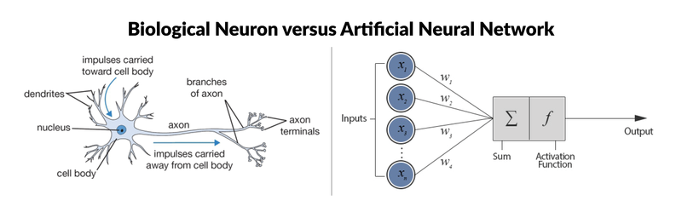
Fig. 1 : [6] A biological neuron (left) and a computational model (right) which is used to develop artificial neural networks.
- Perceptron : basic computational model of Neuron
The most simple neural network is the “perceptron”, which, in its simplest form, consists of a single neuron.
There are six components to artificial neurons. From left to right of Fig 1(right), these are:
a.Input node is associated with a numerical value, which can be any real number.
b. Connection that departs from the input node has a weight associated with it, and this can also be any real number. given as y=f(w1∗x1+w2∗x2+...wD∗xD). This result will be the input for a transfer or activation function. In the simplest but trivial case, this transfer function would be an identity function, f(x)=x or y=x. In this case, x is the weighted sum of the input nodes and the connections. However, just like a biological neuron only fires when a certain threshold is exceeded, the artificial neuron will also only fire when the sum of the inputs exceeds a threshold like the sigmoid function. The weights are adjusted based on the forward propagation technique elaborated in [6].
c. Output node is associated with the function (such as the sigmoid function) of the weighted sum of the input nodes.

d. Bias is an additional parameter in perceptron which you can consider as the weight associated with an additional input node that is permanently set to 1. The bias value is critical because it allows you to shift the activation function to the left or right, which can make a determine the success of your learning. Bias are adjusted based on backward propagation technique elaborated in [6].

- Reading Image by a computer
The machine reads the image not as collectively but as corresponding pixel values of each separate channel represented as matrixes of 3 channels. The RGB color image is separated into its corresponding 3 channels Red, green and blue component. Each of the components has own respective pixel values which are read by the machine. As per Fig 2. The total size of the image is 260x194x3 pixels where there are 260 rows and 194 columns and 3 individual channels which collectively form the RGB color image.
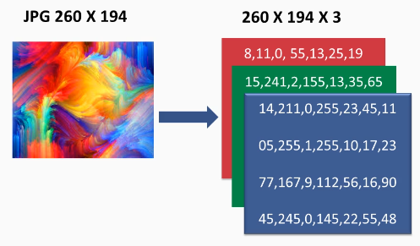
Fig. 2 Image read by computer

Fully Connected network build by multi layer perceptrons is not a feasible approach for Image classification because as per Fig 2 The Fully connected multi perceptron model will have 260*194*132= 151,320 number of weights in the first hidden layer itself. As depicted in Fig 3. Thus directly using fully connected ANN will result in managing large number of parameters and neurons which may result in overfitting problem.

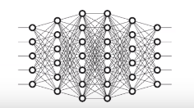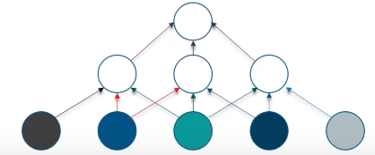
Fig. 3 Fully Connected Neural Network constructed Fig. 4 Convoluted neural network

In case of Convoluted Neural Network the neurons in a layer will be connected to a small region of the layer before it, instead of all Neurons in a fully connected manner which will drastically enhance image segmentation of images.

- Biological Inspiration of Convolution Neural network:
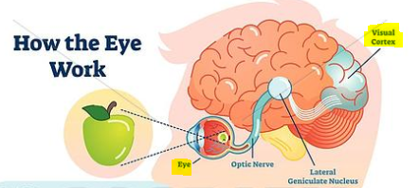
Fig. 5 Visual cortex
CNN is a type of feed forward artificial neural network in which the connectivity pattern between its neuron is inspired by the organization of visual cortex. The visual cortex has a small region of cells that are sensitive to specific regions of the visual field. Some individual neural cells are fired to the presence of edges/orientations and colors. Therefore different neurons will be fired in case of viewing apple than banana for an instance.

[6]CNNs are one of the most popular categories of neural networks, especially for high-dimensional data (e.g., images and videos). CNNs operate in a way that is very similar to standard neural networks. The CNN learns to map a given image to its corresponding category by detecting a number of abstract feature representations, ranging from simple to more complex ones. These discriminative features are then used within the network to predict the correct category of an input image.
Difference of ANN pipeline to CNN is the hierarchy of useful feature representations and its integration of the classification and feature extraction stages in a single pipeline which is trainable in an end-to-end manner. This reduces the need for manual design and expert human intervention.

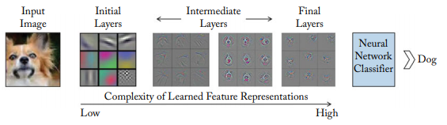
Fig. 6 A CNN learns low-level features in the initial layers, followed by more complex intermediate and high-level feature representations which are used for a classification task. The feature visualizations are adopted from Zeiler and Fergus [2014].

- Layers of CNN:
CNN compares the images piece by piece.The pieces that it looks for is called features. By finding rough feature matches, in roughly the same position in two images,CNN is a lot better at seeing similarity than whole image matching schemes.
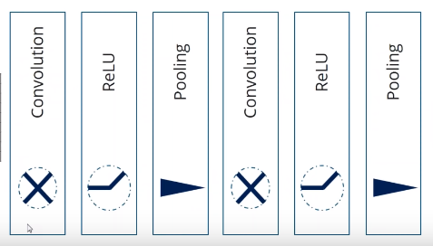
Fig. 7 Stacking multiple layers in CNN

The CNN have the following layers –
- Convolution: A convolutional layer is the most important component of a CNN. It comprises a set of filters (also called convolutional kernels) which are convolved with a given input to generate an output feature map.
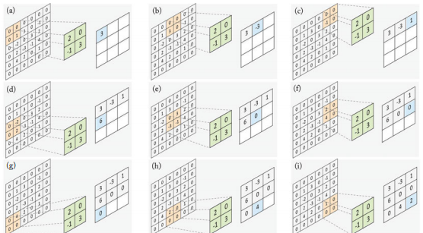
Fig. 8 Example from [6] applying filter in convolution layer to image pixels

The operation of a convolution layer is illustrated in the figure 8 show the computations performed at each step, as the filter is slided onto the input feature map to compute the corresponding value in the output feature map. The 2x2 filter (shown in green) is multiplied with the same sized region (shown in orange) within a 4 4 input feature map and the resulting mean values are corresponding entry (shown in blue) in the output feature map at each convolution step.

- ReLU Layer: In this layer, it removes every negative values from the filtered image and replace it with zeroes.This layer ensures the values don’t sum up to zero. ReLU transform function only activates a node only if the input is above a certain threshold. If the input is below zero, the ouput is zero and when the input rises above a certain threshold it has a linear relationship with dependent variables.
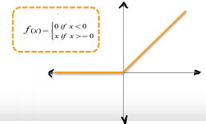
Fig. 9 reLU transform Function

- Pooling : In this Layer we shrink the image stack into a smaller size.
A pooling layer operates on blocks of the input feature map and combines the feature activations. This combination operation is defined by a pooling function such as the average or the max function. Similar to the convolution layer, we need to specify the size of the pooled region and the stride. Figure 4.8 shows the max pooling operation, where the maximum activation is chosen from the selected block of values. This window is slided across the input feature maps with a step size defined by the stride (a in the case of Fig. 10).
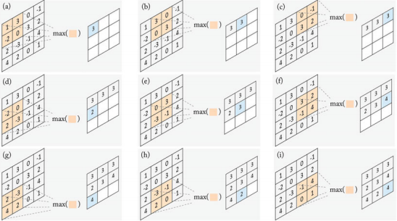
Fig. 10 Pooling with filter and max function

- Fully Connected Layer: This is the final layer where the actual classification happens, here we take our filtered and shrinked images and put them into a single list. This single list will be used by the machine to understand similarities between images and eventually classifies the images into labels based on similarities.

- Proposed Methodology
The Generalized Methodology can be briefly depicted as Fig 11. We are using tf.keras, is TensorFlow's implementation of the Keras API specification. This is a high-level API to build and train models that includes first-class support for TensorFlow-specific functionality, such as eager execution, tf.data pipelines, and Estimators. tf.keras makes TensorFlow easier to use without sacrificing flexibility and performance.
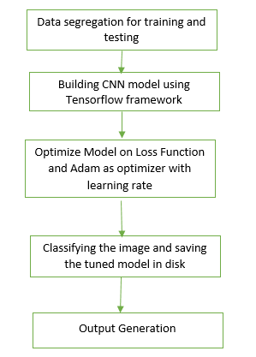
Fig. 11 Generalized Methodology for image classification
TensorFlow framework can be installed using the below command in anaconda command prompt
>> $ conda install tensorflow

  - DataSet:
https://lhncbc.nlm.nih.gov/publication/pub9932
[7]“This page hosts a repository of segmented cells from the thin blood smear slide images from the Malaria Screener research activity. To reduce the burden for microscopists in resource-constrained regions and improve diagnostic accuracy, researchers at the Lister Hill National Center for Biomedical Communications (LHNCBC), part of National Library of Medicine (NLM), have developed a mobile application that runs on a standard Android smartphone attached to a conventional light microscope. Giemsa-stained thin blood smear slides from 150 P. falciparum-infected and 50 healthy patients were collected and photographed at Chittagong Medical College Hospital, Bangladesh. The smartphone’s built-in camera acquired images of slides for each microscopic field of view. The images were manually annotated by an expert slide reader at the Mahidol-Oxford Tropical Medicine Research Unit in Bangkok, Thailand. The de-identified images and annotations are archived at NLM (IRB#12972).”

The dataset repositiory is open sourced for other researchers in field of health and malaria related, [7]The dataset contains a total of 27,558 cell images with equal instances of parasitized and uninfected cells. An instance of how the patient-ID is encoded into the cell name is shown herewith: “P1” denotes the patient-ID for the cell labeled “C33P1thinF_IMG_20150619_114756a_cell_179.png”. We have also included the CSV files containing the Patient-ID to cell mappings for the parasitized/Malaria infected and uninfected classes. The CSV file for the parasitized class contains 151 patient-ID entries. The slide images for the parasitized patient-ID “C47P8thinOriginal” are read from two different microscope models (Olympus and Motif). The CSV file for the uninfected class contains 201 entries since the normal cells from the infected patients’ slides also make it to the normal cell category (151+50 = 201).

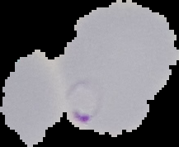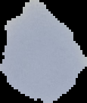
Fig. 12 Sample Images Malaria infected(left) and Uninfected(right)

  - Implementation of CNN using Tensorflow framework
- Importing packages:
The Import Tensorflow and the Keras classes needed to construct our model.
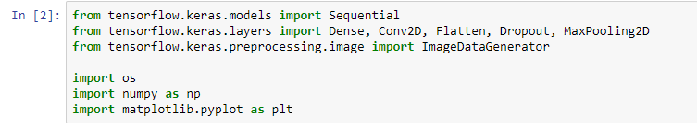
Fig. 13 Importing Keras classes and Tensorflow

- Data segregation of images in file system
The open source repositiory has 12,279 images for parasitized patients(malaria infected blood smear images) and 12,279 images for uninfected patients. We have arranged the file structure containing the dataset as Fig 11 which will be used for label encoding or setting labels for training and validation phase of model. Also we are using 2000 images for training and 1000 for validation randomly selected from original dataset. According to the file structure we will have two labels Parasitized and Uninfected.

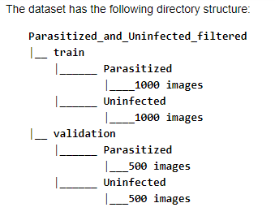
Fig. 14 File Structure using for label encoding
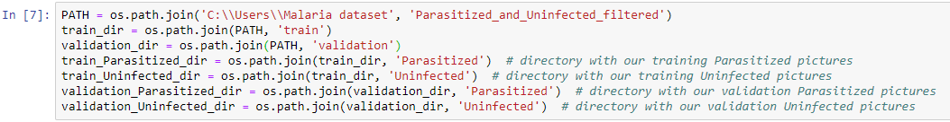
Fig. 15 segregation of images into corresponding dir
- Data Preparation using ImageDataGenerator class
we are considering values for Data preparation in step 4 as: batch_size = 128, epochs = 15, IMG_HEIGHT = 150, IMG_WIDTH = 150. We have to Format the images into appropriately pre-processed floating point tensors before feeding to the network:

- Read images from the disk.
- Decode contents of these images and convert it into proper grid format as per their RGB content.
- Convert them into floating point tensors.
- Rescale the tensors from values between 0 and 255 to values between 0 and 1, as neural networks prefer to deal with small input values.
All these tasks can be done with the ImageDataGenerator class provided by tf.keras. It can read images from disk and preprocess them into proper tensors. It will also set up generators that convert these images into batches of tensors—helpful when training the network. Additionally we apply horizontal flip, zoom augmentation and rotation to avoid overfitting problem in model.

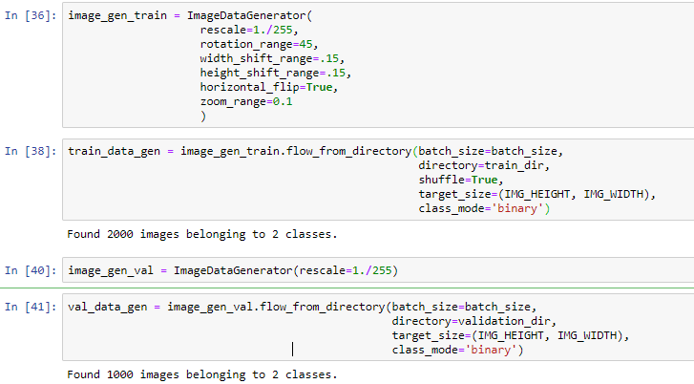
Fig. 16 data preparations

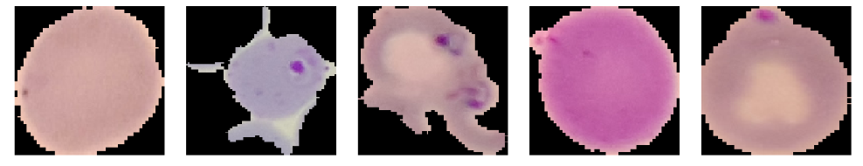
Fig. 17 Datapreparation on images using ImageDataGenerator class

- Creating the Model
The model consists of three convolution blocks with a max pool layer in each of them. There's a fully connected layer with 512 units on top of it that is activated by a reLU activation function. The model outputs class probabilities based on binary classification by the sigmoid activation function. We are using Keras, to assemble layers to build models. A model is (usually) a graph of layers. The most common type of model is a stack of layers: the tf.keras.Sequential model.

We choose the ADAM optimizer and binary cross entropy loss function. To view training and validation accuracy for each training epoch, pass the metrics argument. Additionally we are applying dropout to randomly set 20% of the neurons to zero during each training epoch. This helps to avoid overfitting on the training dataset.
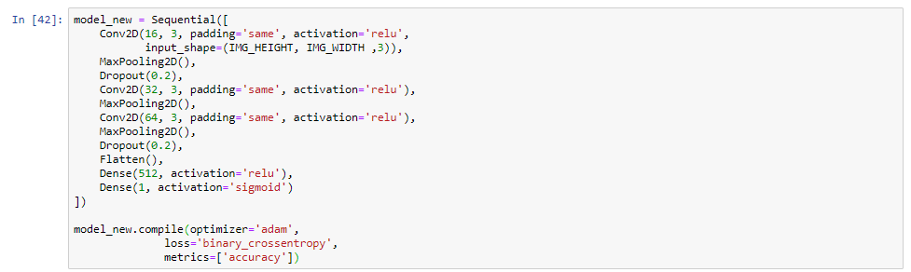
Fig. 18 Sample Sequential Model used for Image classification

- Training and validating the model
Use the fit_generator method of the ImageDataGenerator class to train the network. As in Fig 12 we have achieved an High accuracy of : 0.90

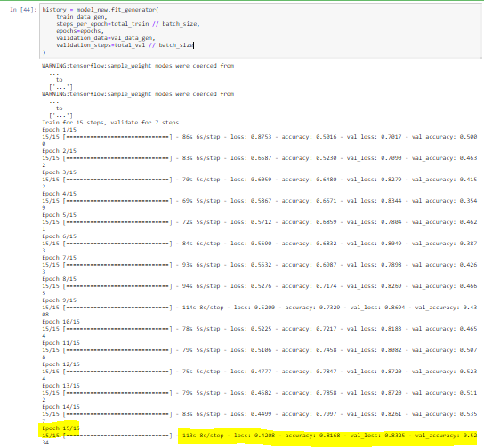
Fig. 19 Training the model for 15 steps and validate for 7 steps

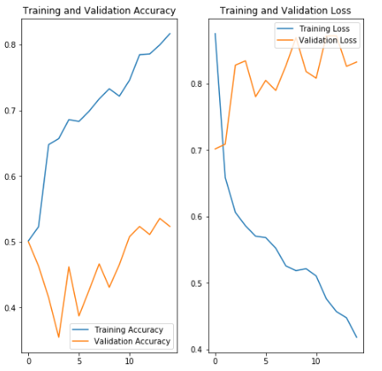
Fig. 20 Graphical representation of validation step
- Saving the model in disk for loading when required
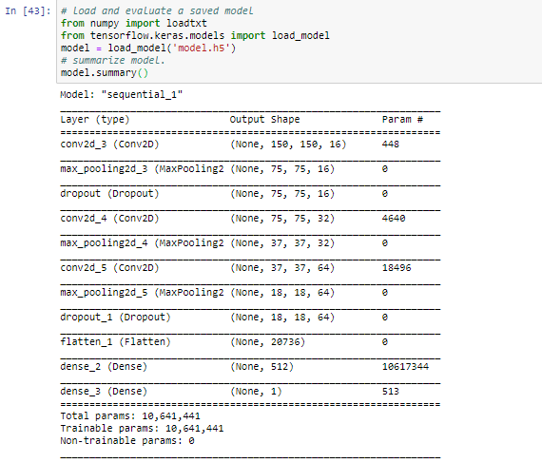
Fig. 21 model parameters are saved for future loading

- applications OF methodology
The proposed system is capable of Rapid detection of malaria in blood smear images This could serve as the answer to eradicating malaria in vulnerable populations that lack access to proper care and reduce the economic burden caused by this crippling disease.

References
[1] BREMAN, JOEL G. “Eradicating Malaria.” Science Progress (1933-), vol. 92, no. 1, 2009, pp. 1–38. JSTOR, www.jstor.org/stable/43423234. Accessed 21 Jan. 2020.
[2] Whitty, Christopher J M, et al. “Investigation and Treatment of Imported Malaria in Non-Endemic Countries.” BMJ: British Medical Journal, vol. 346, no. 7909, 2013, pp. 31–34. JSTOR, www.jstor.org/stable/23494742. Accessed 21 Jan. 2020.
[3] Ribera, Joan Muela, and Susanna Hausmann-Muela. “The Straw That Breaks the Camel's Back Redirecting Health-Seeking Behavior Studies on Malaria and Vulnerability.” Medical Anthropology Quarterly, vol. 25, no. 1, 2011, pp. 103–121., www.jstor.org/stable/23012066. Accessed 21 Jan. 2020.
[4] Kaushik, Jaya Shankar, et al. “Clinical and Epidemiological Profiles of Severe Malaria in Children from Delhi, India.” Journal of Health, Population and Nutrition, vol. 30, no. 1, 2012, pp. 113–116. JSTOR, www.jstor.org/stable/23500113. Accessed 21 Jan. 2020.
[5] Packard, Randall M. “‘Roll Back Malaria, Roll in Development’? Reassessing the Economic Burden of Malaria.” Population and Development Review, vol. 35, no. 1, 2009, pp. 53–87. JSTOR, www.jstor.org/stable/25487642. Accessed 22 Jan. 2020.
[6] Khan, Salman & Rahmani, Hossein & Shah, Syed & Bennamoun, Mohammed. (2018). A Guide to Convolutional Neural Networks for Computer Vision. Synthesis Lectures on Computer Vision. 8. 1-207. 10.2200/S00822ED1V01Y201712COV015.
[7] Rajaraman S, Antani SK, Poostchi M, Silamut K, Hossain MA, Maude, RJ, Jaeger S, Thoma GR. (2018) Pre-trained convolutional neural networks as feature extractors toward improved Malaria parasite detection in thin blood smear images. PeerJ6:e4568 https://doi.org/10.7717/peerj.4568

